HTML Links

HTML links are defined with the **<a>** tag:

Example

<a href="http://www.w3schools.com">This is a link</a>

HTML Images

HTML images are defined with the **<img>** tag.

The source file (**src**), alternative text (**alt**), and size (**width** and **height**) are provided as **attributes**:

Example

<img src="w3schools.jpg" alt="W3Schools.com" width="104" height="142">

Size Attributes

HTML images are defined with the **<img>** tag.

The filename of the source (**src**), and the size of the image (**width** and **height**) are all provided as **attributes**:

Example

<img src="w3schools.jpg" width="104" height="142">

The alt Attribute

The **alt** attribute specifies an alternative text to be used, when an HTML element cannot be displayed.

The value of the attribute can be read by "screen readers". This way, someone "listening" to the webpage, i.e. a blind person, can "hear" the element.

Example

<img src="w3schools.jpg" alt="W3Schools.com" width="104" height="142">

The HTML <pre> Element

The HTML <pre> element defines preformatted text.

The text inside a <pre> element is displayed in a fixed-width font (usually Courier), and it preserves both spaces and line breaks:

Example

<pre>  
  My Bonnie lies over the ocean.  
  
  My Bonnie lies over the sea.  
  
  My Bonnie lies over the ocean.  
  
  Oh, bring back my Bonnie to me.  
</pre>

HTML Text Color

The **color** property defines the text color for an HTML element:

Example

<h1 style="color:blue;">This is a heading</h1>  
<p style="color:red;">This is a paragraph.</p>

HTML Background Color

The **background-color** property defines the background color for an HTML element:

This example sets the background for a page to lightgrey:

HTML Text Alignment

The **text-align** property defines the horizontal text alignment for an HTML element:

Example

<h1 style="text-align:center;">Centered Heading</h1>  
<p>This is a paragraph.</p>

HTML Text Formatting Elements

|  |  |
| --- | --- |
| **Tag** | **Description** |
| [<b>](http://www.w3schools.com/tags/tag_b.asp) | Defines bold text |
| [<em>](http://www.w3schools.com/tags/tag_em.asp) | Defines emphasized text |
| [<i>](http://www.w3schools.com/tags/tag_i.asp) | Defines italic text |
| [<small>](http://www.w3schools.com/tags/tag_small.asp) | Defines smaller text |
| [<strong>](http://www.w3schools.com/tags/tag_strong.asp) | Defines important text |
| [<sub>](http://www.w3schools.com/tags/tag_sub.asp) | Defines subscripted text |
| [<sup>](http://www.w3schools.com/tags/tag_sup.asp) | Defines superscripted text |
| [<ins>](http://www.w3schools.com/tags/tag_ins.asp) | Defines inserted text |
| [<del>](http://www.w3schools.com/tags/tag_del.asp) | Defines deleted text |
| [<mark>](http://www.w3schools.com/tags/tag_mark.asp) | Defines marked/highlighted text |

<del> runs a line through a word.

HTML Quotation and Citation Elements

|  |  |
| --- | --- |
| **Tag** | **Description** |
| [<abbr>](http://www.w3schools.com/tags/tag_abbr.asp) | Defines an abbreviation or acronym |
| [<address>](http://www.w3schools.com/tags/tag_address.asp) | Defines contact information for the author/owner of a document |
| [<bdo>](http://www.w3schools.com/tags/tag_bdo.asp) | Defines the text direction |
| [<blockquote>](http://www.w3schools.com/tags/tag_blockquote.asp) | Defines a section that is quoted from another source |
| [<cite>](http://www.w3schools.com/tags/tag_cite.asp) | Defines the title of a work |
| [<q>](http://www.w3schools.com/tags/tag_q.asp) | Defines a short inline quotation |

<!DOCTYPE html>

<html>

<body>

Make the text below go right-to-left.

<bdo dir= "rtl">What a beautiful day!</bdo>

</body>

</html>

HTML Links - Syntax

In HTML, links are defined with the **<a>** tag:

<a href="*url*">*link text*</a>

<a href="http://www.w3schools.com/html/" target="_blank">Visit our HTML tutorial!</a>

<p>If you set the target attribute to "_blank", the link will open in a new browser window or tab.</p>

|  |  |
| --- | --- |
| **Target Value** | **Description** |
| _blank | Opens the linked document in a new window or tab |
| _self | Opens the linked document in the same frame as it was clicked (this is default) |
| _parent | Opens the linked document in the parent frame |
| _top | Opens the linked document in the full body of the window |
| *framename* | Opens the linked document in a named frame |

HTML Images

Example

<!DOCTYPE html>  
<html>  
<body>  
  
<h2>Spectacular Mountain</h2>  
<img src="pic_mountain.jpg" alt="Mountain View" style="width:304px;height:228px;">  
  
</body>  
</html>

[Try it Yourself »](http://www.w3schools.com/html/tryit.asp?filename=tryhtml_images_mountain)

|  |  |
| --- | --- |
| **Note** | Always specify the width and height of an image. If width and height are not specified, the page will flicker while the image loads. |

Animated Images

The GIF standard allows animated images:

Using an Image as a Link

 To use an image as a link, simply nest the <img> tag inside the <a> tag:

Example

<a href="default.asp">  
  <img src="smiley.gif" alt="HTML tutorial" style="width:42px;height:42px;border:0;">  
</a>

<!DOCTYPE html>

<html>

<body>

<table style="width:100%">

<tr>

<td>Jill</td>

<td>Smith</td>

<td>50</td>

</tr>

<tr>

<td>Eve</td>

<td>Jackson</td>

<td>94</td>

</tr>

<tr>

<td>John</td>

<td>Doe</td>

<td>80</td>

</tr>

</table>

</body>

</html>

|  |  |  |
| --- | --- | --- |
| Jill | Smith | 50 |
| Eve | Jackson | 94 |
| John | Doe | 80 |

ADDING A BORDER

<table border="2" style="width:100%">

CSS PROPERTY

table, th, td {

border: 1px solid black;

}

MAKING BORDERS COLLAPSE

table, th, td {

border: 1px solid black;

border-collapse: collapse;

}

An HTML Table with Cell Padding

Cell padding specifies the space between the cell content and its borders.

If you do not specify a padding, the table cells will be displayed without padding.

To set the padding, use the **CSS padding** property:

Example

table, th, td {  
    border: 1px solid black;  
    border-collapse: collapse;  
}  
th, td {  
    padding: 15px;  
}

HTML Table Headings

Table headings are defined with the **<th>** tag.

By default, all major browsers display table headings as bold and centered:

Example

<table style="width:100%">  
  <tr>  
    <th>Firstname</th>  
    <th>Lastname</th>   
    <th>Points</th>  
  </tr>  
  <tr>  
    <td>Eve</td>  
    <td>Jackson</td>   
    <td>94</td>  
  </tr>  
</table>

To left-align the table headings, use the **CSS text-align** property:

Example

th {  
    text-align: left;  
}

An HTML Table with Border Spacing

Border spacing specifies the space between the cells.

To set the border spacing for a table, use the **CSS border-spacing** property:

Example

table {  
    border-spacing: 5px;  
}

Table Cells that Span Many Columns

To make a cell span more than one column, use the **colspan** attribute:

Example

<table style="width:100%">  
  <tr>  
    <th>Name</th>  
    <th colspan="2">Telephone</th>  
  </tr>  
  <tr>  
    <td>Bill Gates</td>  
    <td>555 77 854</td>  
    <td>555 77 855</td>  
  </tr>  
</table>

Table Cells that Span Many Rows

To make a cell span more than one row, use the **rowspan** attribute:

Example

<table style="width:100%">  
  <tr>  
    <th>Name:</th>  
    <td>Bill Gates</td>  
  </tr>  
  <tr>  
    <th rowspan="2">Telephone:</th>  
    <td>555 77 854</td>  
  </tr>  
  <tr>  
    <td>555 77 855</td>  
  </tr>  
</table>

An HTML Table With a Caption

To add a caption to a table, use the **<caption>** tag:

Example

<table style="width:100%">  
  <caption>Monthly savings</caption>  
  <tr>  
    <th>Month</th>  
    <th>Savings</th>  
  </tr>  
  <tr>  
    <td>January</td>  
    <td>$100</td>  
  </tr>  
  <tr>  
    <td>February</td>  
    <td>$50</td>  
  </tr>  
</table>

A Special Style for One Table

To define a special style for a special table, add an **id attribute** to the table:

Example

<table id="t01">  
  <tr>  
    <th>Firstname</th>  
    <th>Lastname</th>   
    <th>Points</th>  
  </tr>  
  <tr>  
    <td>Eve</td>  
    <td>Jackson</td>   
    <td>94</td>  
  </tr>  
</table>

Now you can define a special style for this table:

table#t01 {  
    width: 100%;   
    background-color: #f1f1c1;  
}

Add a black background color with white text to all table rows.

<style>

table, th, td {

border: 1px solid black;

text-align: left;

}

tr {

background-color: black;

color: white;

}

Unordered HTML Lists - The Style Attribute

A **style** attribute can be added to an **unordered list**, to define the style of the marker:

|  |  |
| --- | --- |
| **Style** | **Description** |
| list-style-type:disc | The list items will be marked with bullets (default) |
| list-style-type:circle | The list items will be marked with circles |
| list-style-type:square | The list items will be marked with squares |
| list-style-type:none | The list items will not be marked |

Ordered HTML Lists - The Type Attribute

A **type** attribute can be added to an **ordered list**, to define the type of the marker:

|  |  |
| --- | --- |
| **Type** | **Description** |
| type="1" | The list items will be numbered with numbers (default) |
| type="A" | The list items will be numbered with uppercase letters |
| type="a" | The list items will be numbered with lowercase letters |
| type="I" | The list items will be numbered with uppercase roman numbers |
| type="i" | The list items will be numbered with lowercase roman numbers |

HTML Description Lists

HTML also supports description lists.

A description list is a list of terms, with a description of each term.

The **<dl>** tag defines the description list, the **<dt>** tag defines the term (name), and the **<dd>** tag describes each term:

<!DOCTYPE html>

<html>

<body>

<h2>A Description List</h2>

<dl>

<dt>Coffee</dt>

<dd>- black hot drink</dd>

<dt>Milk</dt>

<dd>- white cold drink</dd>

</dl>

</body>

</html>

HORIZONTAL LISTS

<!DOCTYPE html>  
<html>  
  
<head>  
<style>  
ul#menu li {  
    display:inline;  
}  
</style>  
</head>  
  
<body>  
  
<h2>Horizontal List</h2>  
  
<ul id="menu">  
  <li>HTML</li>  
  <li>CSS</li>  
  <li>JavaScript</li>  
  <li>PHP</li>  
</ul>   
  
</body>  
</html

AN IFRAME IS USED TO DISPLAY A PAGE WITHIN A PAGE

Iframe Syntax

The syntax for adding an iframe is:

<iframe src="*URL*"></iframe>

Iframe - Set Height and Width

Use the **height** and **width** attributes to specify the size.

The attribute values are specified in pixels by default, but they can also be in percent (like "80%").

Example

<iframe src="demo_iframe.htm" width="200" height="200"></iframe>

Iframe - Remove the Border

By default, an iframe has a black border around it.

To remove the border, add the style attribute and use the CSS border property:

Example

<iframe src="demo_iframe.htm" style="border:none"></iframe>

Use iframe as a Target for a Link

An iframe can be used as the target frame for a link.

The **target** attribute of the link must refer to the **name** attribute of the iframe:

Example

<iframe src="demo_iframe.htm" name="iframe_a"></iframe>  
<p><a href="http://www.w3schools.com" target="iframe_a">W3Schools.com</a></p>

HTML Script Tags

|  |  |
| --- | --- |
| **Tag** | **Description** |
| [<script>](http://www.w3schools.com/tags/tag_script.asp) | Defines a client-side script |
| [<noscript>](http://www.w3schools.com/tags/tag_noscript.asp) | Defines an alternate content for users that do not support client-side scripts |

[Insert a script](http://www.w3schools.com/html/tryit.asp?filename=tryhtml_script)  
How to insert a JavaScript into an HTML document.

<!DOCTYPE html>

<html>

<body>

<p id="demo"></p>

<script>

document.getElementById("demo").innerHTML = "Hello JavaScript!";

</script>

</body>

</html>

HTML Script Tags

|  |  |
| --- | --- |
| **Tag** | **Description** |
| [<script>](http://www.w3schools.com/tags/tag_script.asp) | Defines a client-side script |
| [<noscript>](http://www.w3schools.com/tags/tag_noscript.asp) | Defines an alternate content for users that do not support client-side scripts |

The <form> Element

HTML forms are used to collect user input.

The **<form>** element defines an HTML form:

<form>  
.  
*form elements*  
.  
</form>

Top of Form

First name:  
   
Last name:  


Bottom of Form

Note that the form itself is not visible.

Also note that the default width of a text input field is 20 characters.

<!DOCTYPE html>

<html>

<body>

<form>

First name:<br>

<input type="text" name="firstname">

<br>

Last name:<br>

<input type="text" name="lastname">

</form>

<p>Note that the form itself is not visible.</p>

<p>Also note that the default width of a text input field is 20 characters.</p>

</body>

</html>

Radio Button Input

**<input type="radio">** defines a **radio button**.

Radio buttons let a user select ONE of a limited number of choices:

Example

<form>  
  <input type="radio" name="gender" value="male" checked> Male<br>  
  <input type="radio" name="gender" value="female"> Female<br>  
  <input type="radio" name="gender" value="other"> Other  
</form>

[Try it Yourself »](http://www.w3schools.com/html/tryit.asp?filename=tryhtml_form_radio)

This is how the HTML code above will be displayed in a browser:

 Male  
 Female  
 Other

Top of Form

First name:  
   
Last name:  
   
  


Bottom of Form

If you click the "Submit" button, the form-data will be sent to a page called "action_page.php".

The Action Attribute

The **action attribute** defines the action to be performed when the form is submitted.

The common way to submit a form to a server, is by using a submit button.

Normally, the form is submitted to a web page on a web server.

In the example above, a server-side script is specified to handle the submitted form:

<form **action="action_page.php**">

If the action attribute is omitted, the action is set to the current page.

The Method Attribute

The **method attribute** specifies the HTTP method (**GET**or **POST**) to be used when submitting the forms:

<form action="action_page.php" **method="get"**>

or:

<form action="action_page.php" **method="post"**>

<!DOCTYPE html>

<html>

<body>

<form action="action_page.php">

First name:<br>

<input type="text" name="firstname" value="Mickey">

<br>

Last name:<br>

<input type="text" name="lastname" value="Mouse">

<br><br>

<input type="submit" value="Submit">

</form>

<p>If you click the "Submit" button, the form-data will be sent to a page called "action_page.php".</p>

</body>

</html>

Grouping Form Data with <fieldset>

The **<fieldset>** element groups related data in a form.

The **<legend>** element defines a caption for the <fieldset> element.

Example

<form action="action_page.php">  
  <fieldset>  
    <legend>Personal information:</legend>  
    First name:<br>  
    <input type="text" name="firstname" value="Mickey"><br>  
    Last name:<br>  
    <input type="text" name="lastname" value="Mouse"><br><br>  
    <input type="submit" value="Submit">  
  </fieldset>  
</form>

[Try it Yourself »](http://www.w3schools.com/html/tryit.asp?filename=tryhtml_form_legend)

This is how the HTML code above will be displayed in a browser:

Top of Form

Personal information:First name:  
   
Last name:  
   
  


<!DOCTYPE html>

<html>

<body>

<form>

<input type= "button" value ="OK">

<form>

</body>

</html>

Makes a button

#### Self-Closing Elements

In the previous example, the <meta> element had only one tag and didn’t include a closing tag. Fear not, this was intentional. Not all elements consist of opening and closing tags. Some elements simply receive their content or behavior from attributes within a single tag. The <meta> element is one of these elements. The content of the previous <meta> element is assigned with the use of the charset attribute and value. Other common selfclosing elements include

* <br>
* <embed>
* <hr>
* <img>
* <input>
* <link>
* <meta>
* <param>
* <source>
* <wbr>

## Identifying Divisions & Spans[#divs-and-spans](http://learn.shayhowe.com/html-css/getting-to-know-html/#divs-and-spans)

* Divisions, or <div>s, and <span>s are HTML elements that act as containers solely for styling purposes. As generic containers, they do not come with any overarching meaning or semantic value. Paragraphs are semantic in that content wrapped within a<p> element is known and understood as a paragraph. <div>s and <span>s do not hold any such meaning and are simply containers.
* Both <div>s and <span>s, however, are extremely valuable when building a website in that they give us the ability to apply targeted styles to a contained set of content.
* A <div> is a block-level element that is commonly used to identify large groupings of content, and which helps to build a web page’s layout and design. A <span>, on the other hand, is an inline-level element commonly used to identify smaller groupings of text within a block-level element.
* We’ll commonly see <div>s and <span>s with class or id attributes for styling purposes. Choosing a class or id attribute value, or name, requires a bit of care. We want to choose a value that refers to the content of an element, not necessarily the appearance of an element.
* For example, if we have a <div> with an orange background that contains social media links, our first thought might be to give the <div> a class value of orange. What happens if that orange background is later changed to blue? Having a class value oforange no longer makes sense. A more sensible choice for a class value would besocial, as it pertains to the contents of the <div>, not the style.

#### Comments within HTML & CSS

* The previous code includes exclamation points within the HTML, and that’s all right. Those are not elements, those are comments.
* HTML and CSS give us the ability to leave comments within our code, and any content wrapped within a comment will not be displayed on the web page. Comments help keep our files organized, allow us to set reminders, and provide a way for us to more effectively manage our code. Comments become especially useful when there are multiple people working on the same files.
* HTML comments start with <!-- and end with -->. CSS comments start with/* and end with */.

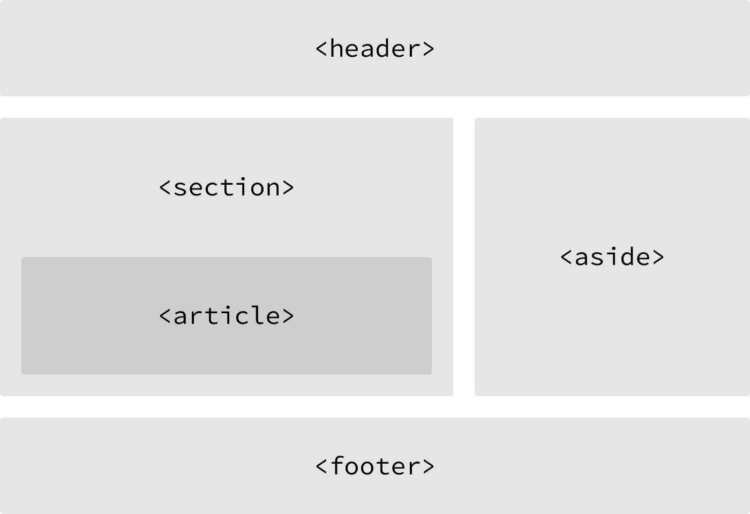

**Linking to an Email Address**

Occasionally we may want to create a hyperlink to our email address—for example, hyperlink text that says “Email Me,” which when clicked opens a user’s default email client and pre-populates part of an email. At a minimum the email address to which the email is being sent is populated; other information such as a subject line and body text may also be included.

To create an [email link](https://yoast.com/guide-mailto-links/), the href attribute value needs to start with mailto: followed by the email address to which the email should be sent. To create an email link toshay@awesome.com, for example, the href attribute value would bemailto:shay@awesome.com.

Additionally, subject, body text, and other information for the email may be populated. To add a subject line, we’ll include the subject= parameter after the email address. The first parameter following the email address must begin with a question mark, ?, to bind it to the hyperlink path. Multiple words within a subject line require that spaces be encoded using %20.

Adding body text works in the same way as adding the subject, this time using thebody= parameter in the href attribute value. Because we are binding one parameter to another we need to use the ampersand, &, to separate the two. As with the subject, spaces must be encoded using %20, and line breaks must be encoded using %0A.

Altogether, a link to shay@awesome.com with the subject of “Reaching Out” and body text of “How are you” would require an href attribute value of mailto:shay@awesome.com?subject=Reaching%20Out&body=How%20are%20you.

Here’s the full breakdown:

|  |  |
| --- | --- |
| 1  2 | <a href="mailto:shay@awesome.com?subject=Reaching%20Out&body=How%20are%20you">Email Me</a> |

**Opening Links in a New Window**

One feature available with hyperlinks is the ability to determine where a link opens when clicked. Typically, links open in the same window from which they are clicked; however, links may also be opened in new windows.

To trigger the action of opening a link in a new window, use the target attribute with a value of _blank. The target attribute determines exactly where the link will be displayed, and the _blank value specifies a new window.

To open http://shayhowe.com/ in a new window, the code would look like this:

|  |  |
| --- | --- |
| 1  2 | <a href="http://shayhowe.com/" target="_blank">Shay Howe</a> |

Bottom of Form